1. **Create one VPC in N.virginia region.**

**Step 1: Select N. Virginia Region**

1. **Go to the AWS Management Console**
2. **In the top-right corner, click on the region selector**
3. **Select N. Virginia (us-east-1)**

**Step 2: Go to VPC Dashboard**

1. **In the Services menu, search for VPC**
2. **Click “VPC Dashboard”**

**Step 3: Create a VPC**

1. **Click “Create VPC”**
2. **Choose “VPC only” option**

**Step 4: Configure VPC Settings**

1. **Name tag: MyVPC (or any name)**
2. **IPv4 CIDR block: 10.0.0.0/16 (or your preferred block)**
3. **Leave IPv6 CIDR block as "No IPv6 CIDR block"**
4. **Tenancy: Default**
5. **Click Create VPC**

**Step 5: Confirm VPC Creation**

1. **After successful creation, click “View VPC”**
2. **You will see your VPC listed with the specified CIDR**

**Done! You've successfully created a VPC in the N. Virginia region.**

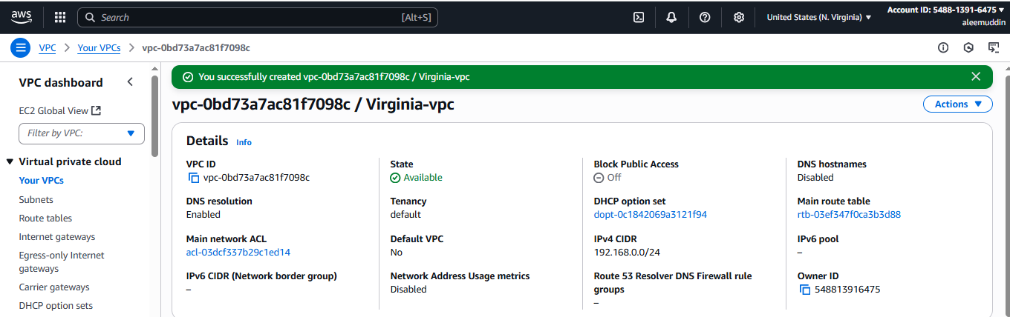

1. **Create two subnets. One Public subnet and one private subnet.**

**Step 1: Go to VPC Dashboard**

1. **Open AWS Console**
2. **Go to VPC → Subnets**
3. **Click “Create subnet”**

**Step 2: Create Public Subnet**

1. **VPC ID: Select your VPC (e.g., MyVPC)**
2. **Subnet name: PublicSubnet**
3. **Availability Zone: Choose one (e.g., us-east-1a)**
4. **IPv4 CIDR block: e.g., 10.0.1.0/24**
5. **Click Create subnet**

**Step 3: Create Private Subnet**

1. **Click “Create subnet” again**
2. **VPC ID: Same VPC**
3. **Subnet name: PrivateSubnet**
4. **Availability Zone: Choose another or same (e.g., us-east-1b)**
5. **IPv4 CIDR block: e.g., 10.0.2.0/24**
6. **Click Create subnet**

**Step 4: Make the Public Subnet Public**

1. **Go to VPC → Route Tables**
2. **Find the main or custom route table associated with PublicSubnet**
3. **Edit routes:**
   * **Add route: 0.0.0.0/0 → target Internet Gateway**
4. **Go to Subnet Associations**
   * **Associate the route table with PublicSubnet**

**Done!**

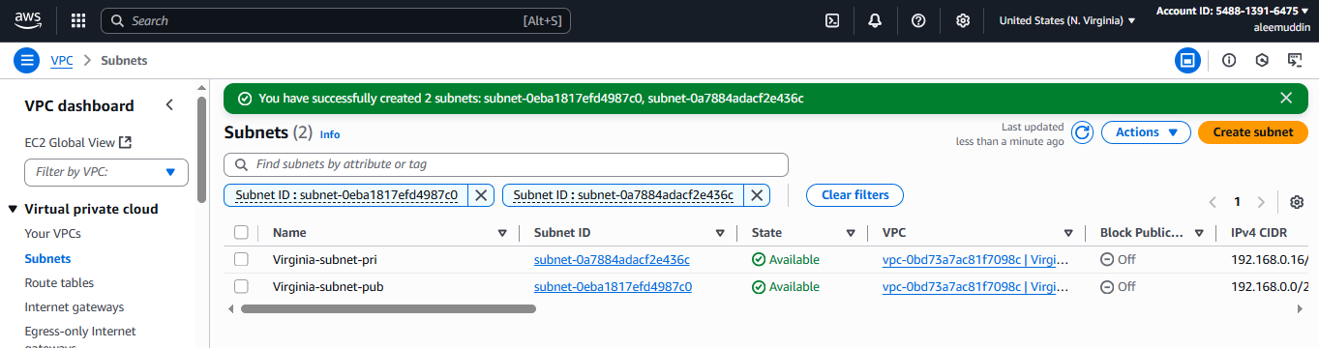

1. **Provide the IGW to the vpc.**

**Step 1: Go to VPC Dashboard**

1. **Open AWS Console**
2. **Navigate to VPC → Internet Gateways**

**Step 2: Create Internet Gateway**

1. **Click “Create internet gateway”**
2. **Name tag: MyIGW (or any name)**
3. **Click Create internet gateway**

**Step 3: Attach IGW to Your VPC**

1. **After creating, click “Actions → Attach to VPC”**
2. **Select your VPC (e.g., MyVPC)**
3. **Click Attach internet gateway**

**Done! The IGW is now attached to your VPC, allowing public subnets with the correct route to access the internet.**

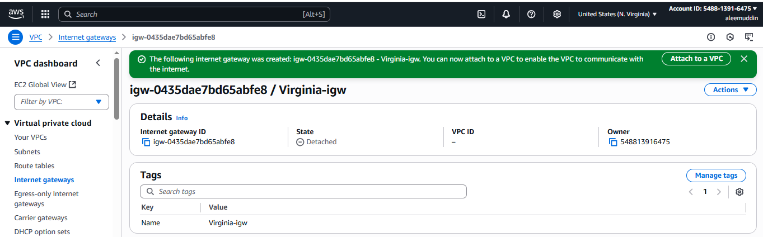

1. **Create one public RT and one private RT.**

**Step 1: Go to VPC Dashboard**

1. **Open AWS Console**
2. **Navigate to VPC → Route Tables**
3. **Click “Create route table”**

**Step 2: Create Public Route Table**

1. **Name tag: PublicRT**
2. **VPC: Select your VPC**
3. **Click Create route table**

**Step 3: Edit Public Route Table for Internet Access**

1. **Select PublicRT → Click “Routes” → Edit routes**
2. **Add route:**
   * **Destination: 0.0.0.0/0**
   * **Target: Select your Internet Gateway (IGW)**
3. **Click Save changes**

**Step 4: Create Private Route Table**

1. **Go back to Route Tables**
2. **Click “Create route table”**
3. **Name tag: PrivateRT**
4. **VPC: Select the same VPC**
5. **Click Create route table**

**Done! You now have:**

* **PublicRT with a route to the internet**
* **PrivateRT for private subnet traffic with Nat gateway**

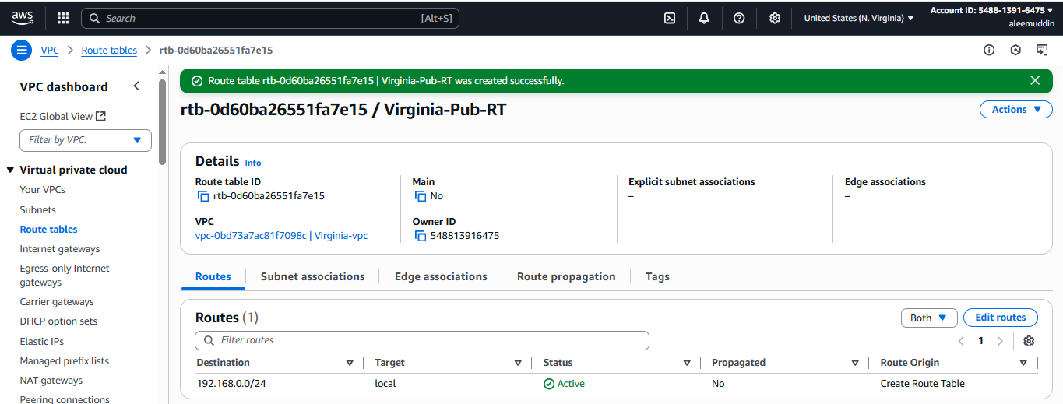

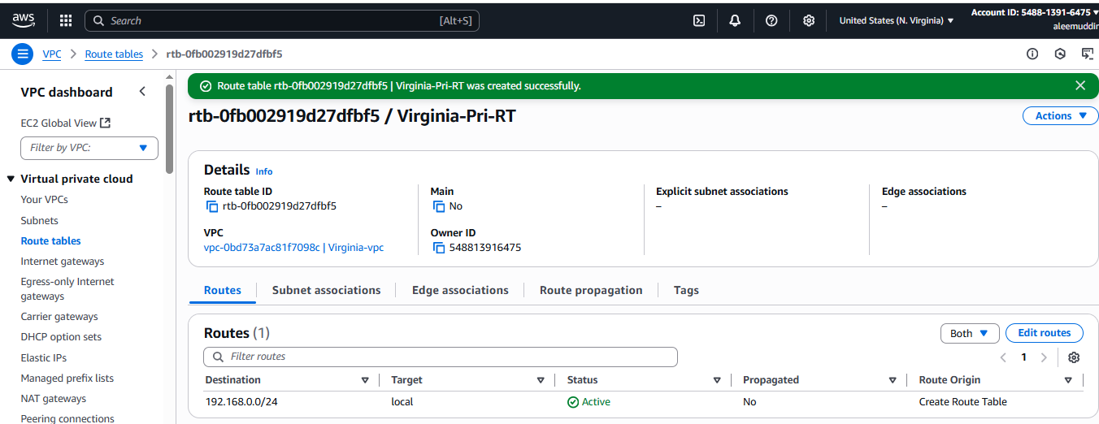

1. **Deploy NAT gateway on public subnet and attach the NAT gatewat to private subnet.**

**Step 1: Allocate an Elastic IP**

1. **Go to EC2 → Elastic IPs**
2. **Click “Allocate Elastic IP address”**
3. **Click Allocate**

**Step 2: Create NAT Gateway in Public Subnet**

1. **Go to VPC → NAT Gateways**
2. **Click “Create NAT Gateway”**
3. **Name: MyNATGateway**
4. **Subnet: Select your Public Subnet**
5. **Elastic IP: Select the EIP you just allocated**
6. **Click Create NAT Gateway**

**Step 3: Update Private Route Table**

1. **Go to VPC → Route Tables**
2. **Select your Private Route Table**
3. **Click “Routes” → Edit routes**
4. **Add a route:**
   * **Destination: 0.0.0.0/0**
   * **Target: Select the NAT Gateway**
5. **Click Save changes**

**Done! Now, instances in your private subnet can access the internet via the NAT Gateway, while still remaining inaccessible from outside.**

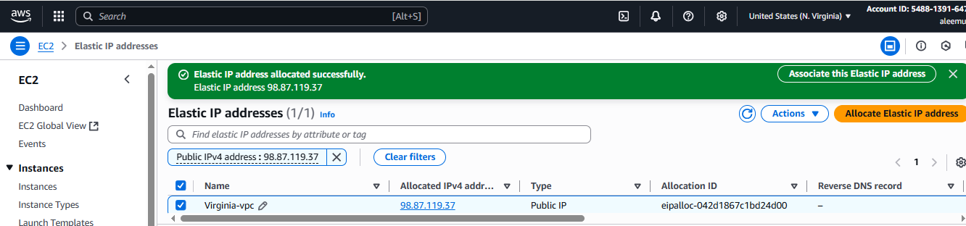

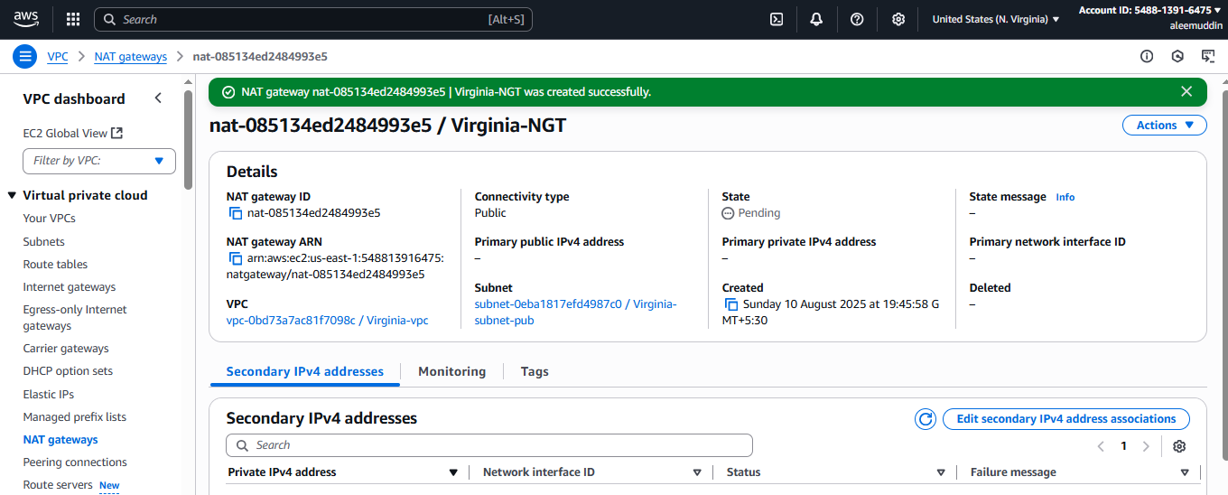

1. **Create Two instances,one in public subnet and one in private subnet.**

**Step 1: Go to EC2 Console**

1. Open **AWS Console**
2. Navigate to **EC2 → Instances**
3. Click **“Launch instance”**

**Step 2: Create Instance in Public Subnet**

1. **Name**: PublicInstance
2. **AMI**: Choose Amazon Linux 2 or preferred AMI
3. **Instance type**: t2.micro (free tier eligible)
4. **Key pair**: Select or create a key pair
5. **Network settings**:
   * **VPC**: Select your VPC
   * **Subnet**: Choose **Public Subnet**
   * **Auto-assign public IP**: **Enable**
   * **Security group**: Allow SSH (port 22)
6. Click **Launch Instance**

**Step 3: Create Instance in Private Subnet**

1. Go back to **Launch Instance**
2. **Name**: PrivateInstance
3. **AMI**: Same as above
4. **Instance type**: t2.micro
5. **Key pair**: Same or new key pair
6. **Network settings**:
   * **VPC**: Same VPC
   * **Subnet**: Choose **Private Subnet**
   * **Auto-assign public IP**: **Disable**
   * **Security group**: Allow SSH from the **PublicInstance**'s private IP
7. Click **Launch Instance**

Done!

* PublicInstance can be accessed via the internet
* PrivateInstance can be accessed **via SSH from the PublicInstance** (using private IP) if required.

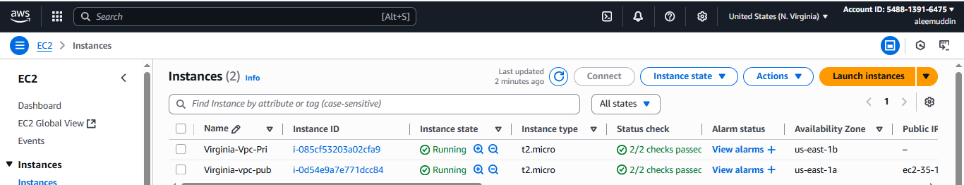

1. **Deploy Apache server on both the ec2 instances with sample index.html file.**

**Step 1: Connect to Each EC2 Instance via SSH**

**Use your key pair to SSH into each instance:**

**bash**

**CopyEdit**

**ssh -i key.pem ec2-user@<public-ip>**

**Step 2: Install Apache Web Server**

**Run the following commands on both instances:**

**bash**

**CopyEdit**

**sudo yum update -y # For Amazon Linux**

**sudo yum install httpd -y**

**Step 3: Start and Enable Apache**

**bash**

**CopyEdit**

**sudo systemctl start httpd**

**sudo systemctl enable httpd**

**Step 4: Add Sample index.html Page**

**bash**

**CopyEdit**

**echo "<h1>Welcome to Apache on $(hostname)</h1>" | sudo tee /var/www/html/index.html**

**Step 5: Adjust Security Group (for Public Instance)**

1. **Go to EC2 → Security Groups**
2. **Edit Inbound Rules of the Public Instance**
   * **Add rule: HTTP | Port: 80 | Source: 0.0.0.0/0**

**Done!**

* **You can access the public instance in a browser using:  
  http://<public-ip>**

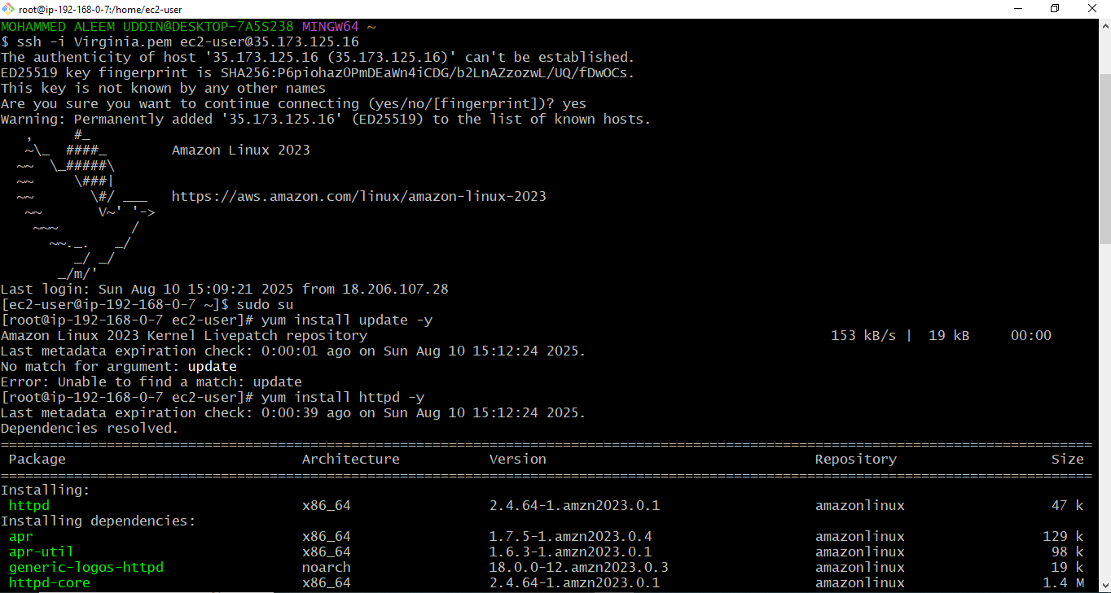

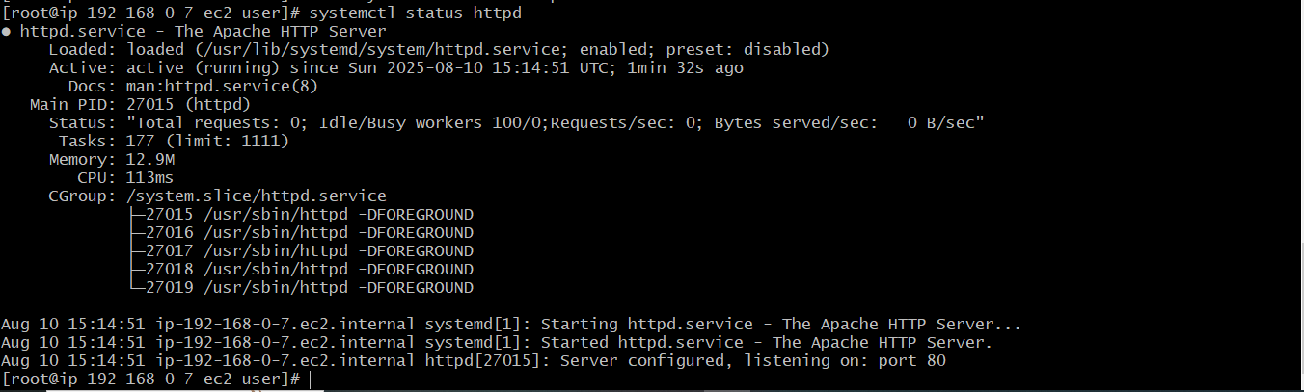

**Without adding sample index.html file**

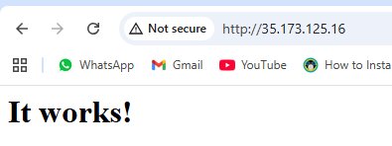

**After added sample index.html file**

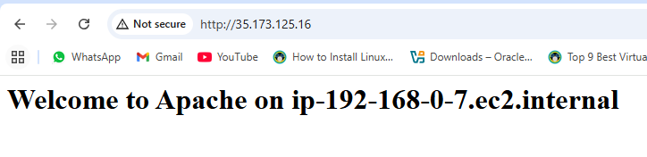

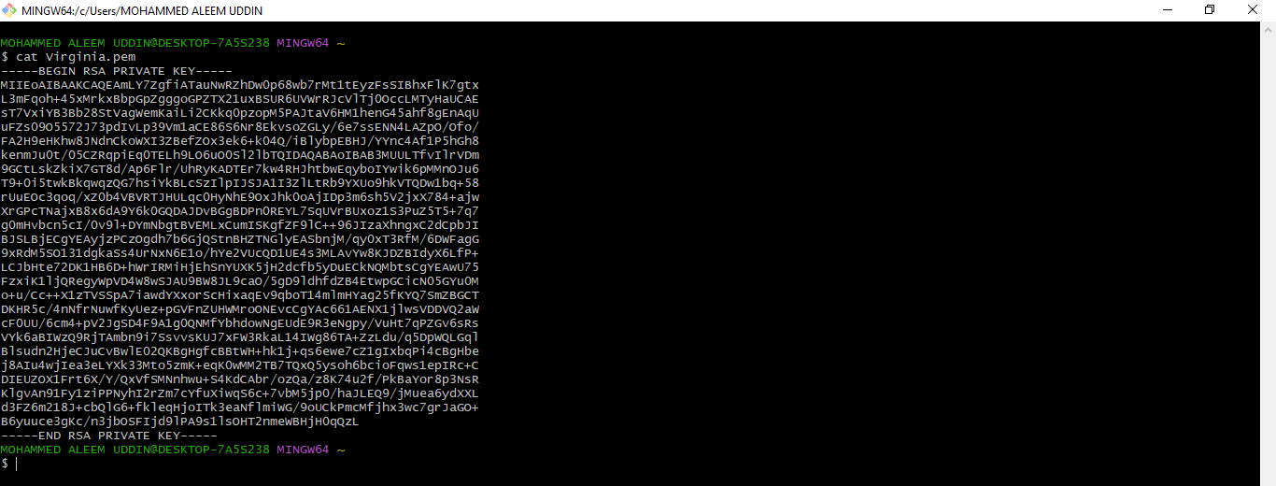

**Here we are copying the private key from .pem file**

**Here we have jump from public to private by pasting private key and giving permission chmod 600 to Virginia.pem**

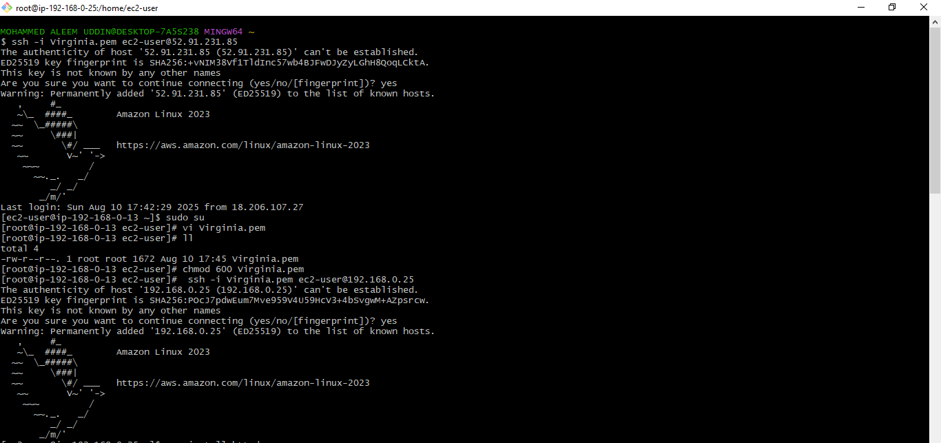

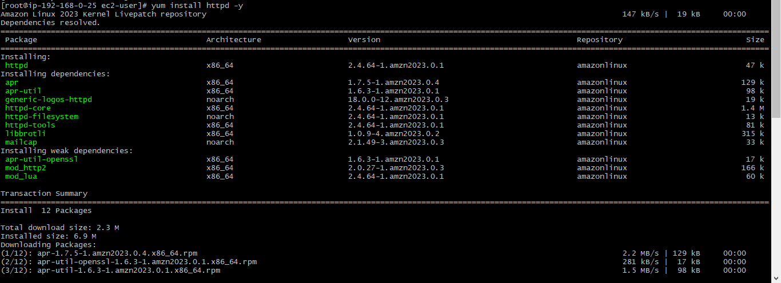

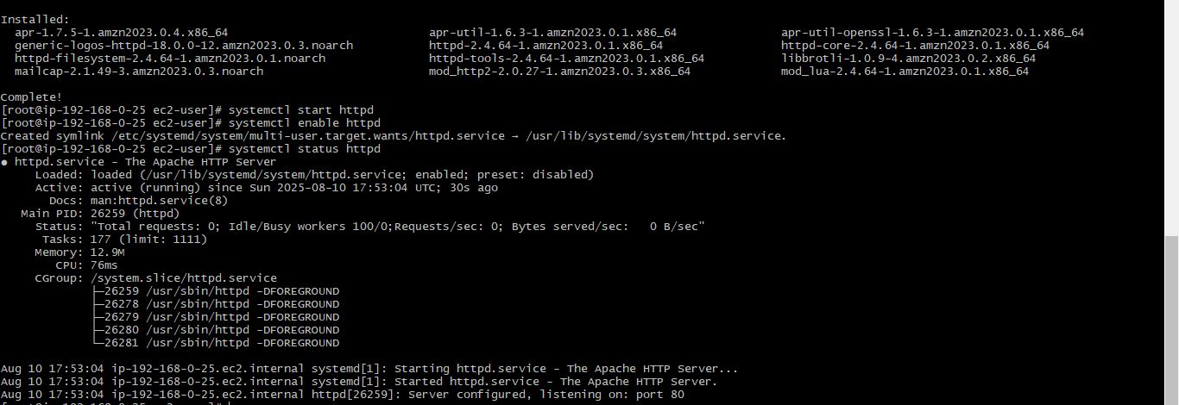

**Here we have done curl to check the service working or not for private network.**



1. **Create one application load balancer and attach the load balancer to both the ec2 instances.**

**Step 1: Go to EC2 Console → Load Balancers**

1. **Open AWS Console**
2. **Navigate to EC2 → Load Balancers**
3. **Click “Create Load Balancer”**
4. **Choose Application Load Balancer → Click Create**

**Step 2: Configure Load Balancer**

1. **Name: MyALB**
2. **Scheme: internet-facing**
3. **IP address type: IPv4**
4. **Listeners: HTTP (port 80) is default**
5. **Availability Zones:**
   * **Select your VPC**
   * **Check both subnets (public ones) for different AZs**

**Step 3: Configure Security Group**

1. **Select or create a Security Group that allows inbound HTTP (port 80)**

**Step 4: Configure Target Group**

1. **Target group name: MyTargetGroup**
2. **Target type: Instance**
3. **Protocol: HTTP | Port: 80**
4. **VPC: Choose your VPC**
5. **Click Next**

**Step 5: Register Targets (EC2 Instances)**

1. **Select both EC2 instances (public and private)**
2. **Click Add to registered**
3. **Click Create target group**

**Step 6: Review and Create ALB**

1. **Go back to ALB config**
2. **Select the target group you just created**
3. **Review and click Create load balancer**

**Done!  
Your Application Load Balancer now distributes traffic to both EC2 instances. You can access it via the ALB's DNS name shown in the EC2 → Load Balancer dashboard.**

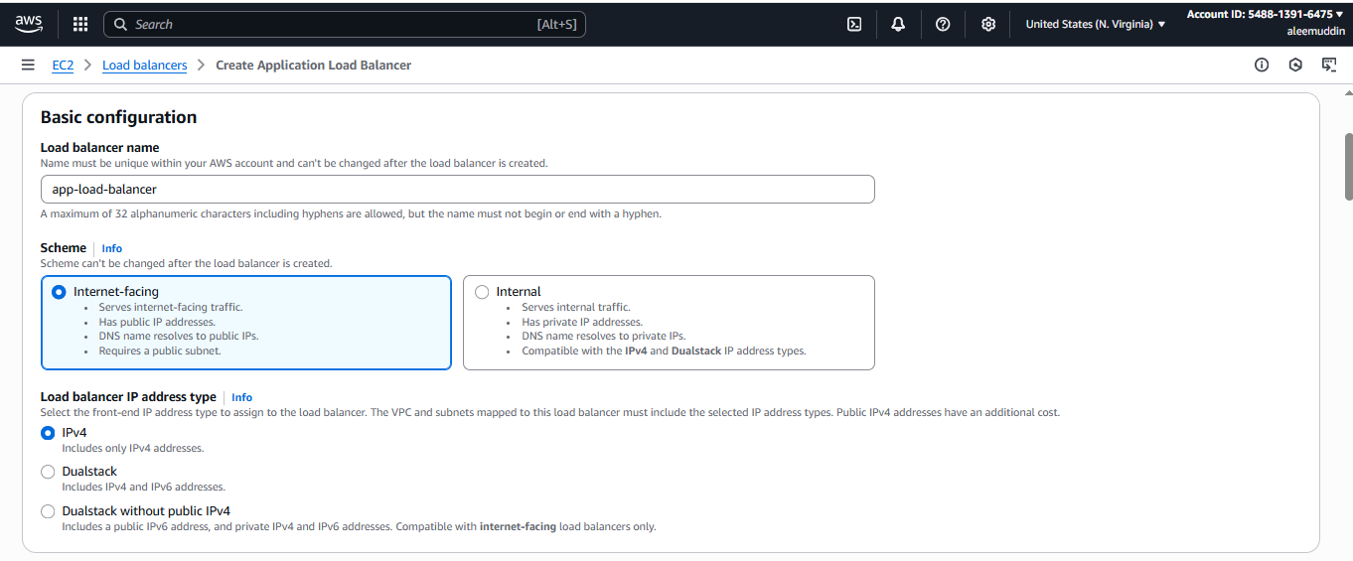

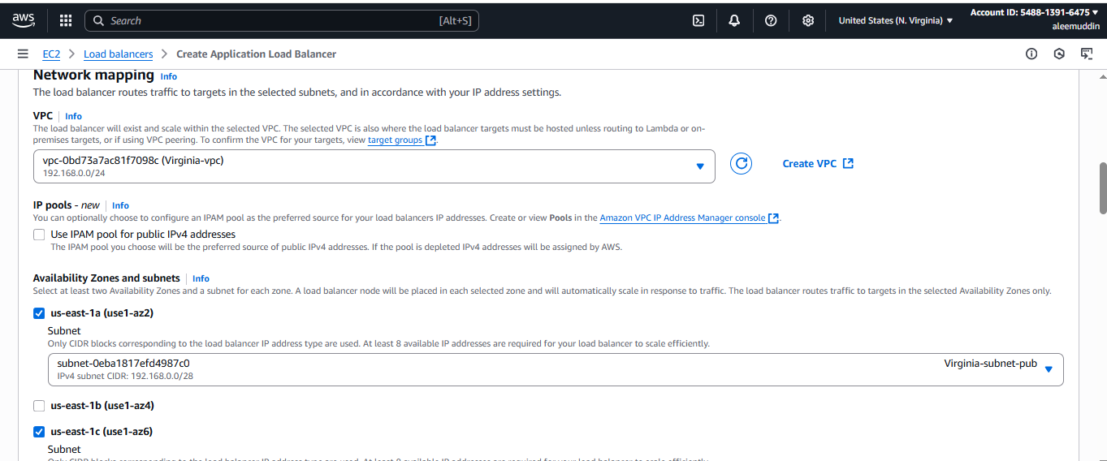

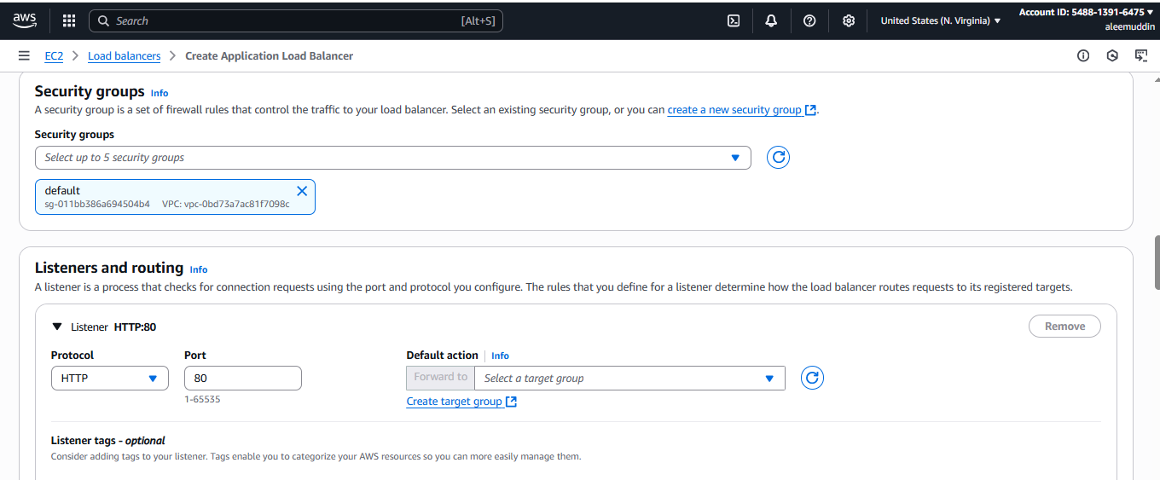

**Here we are creating target group**

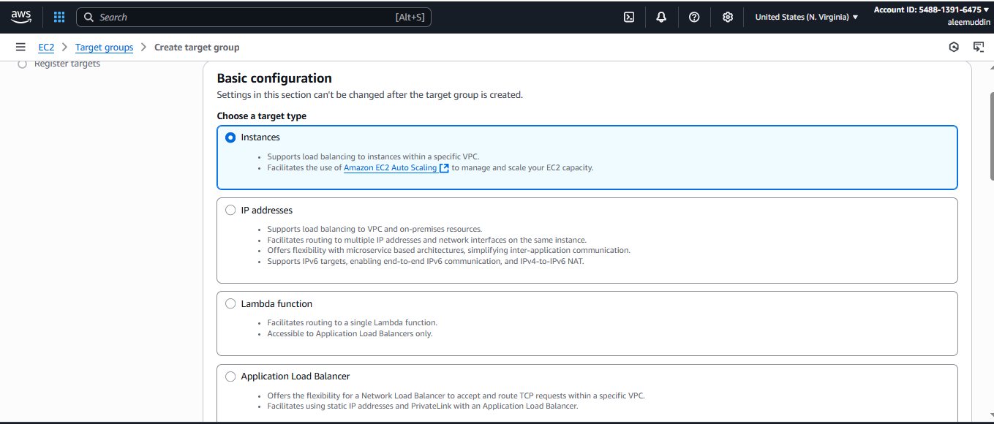

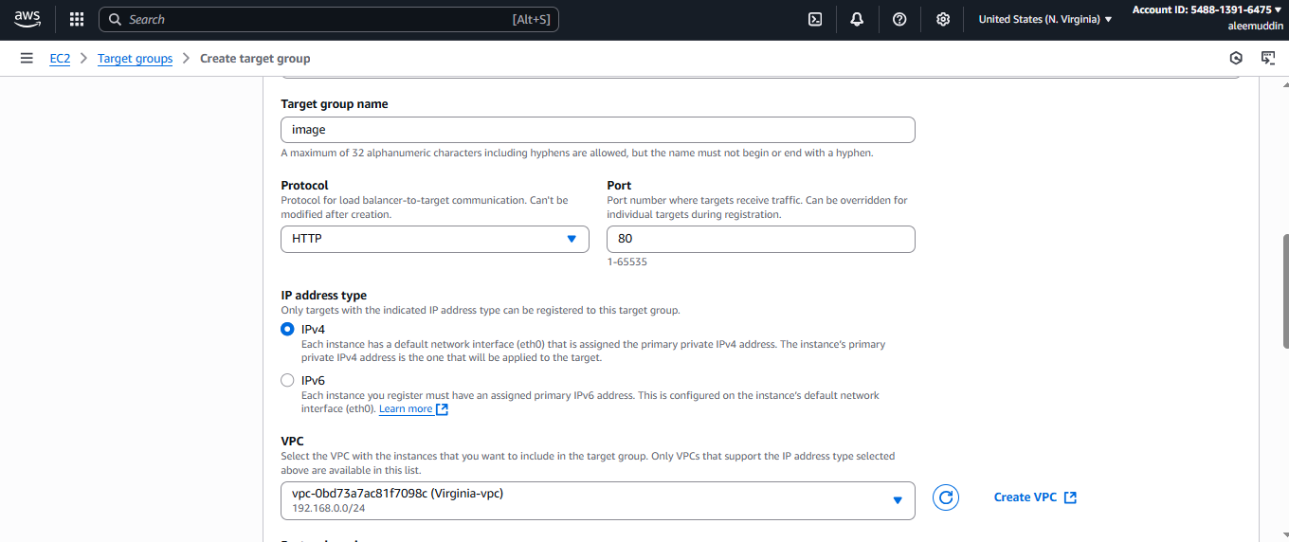

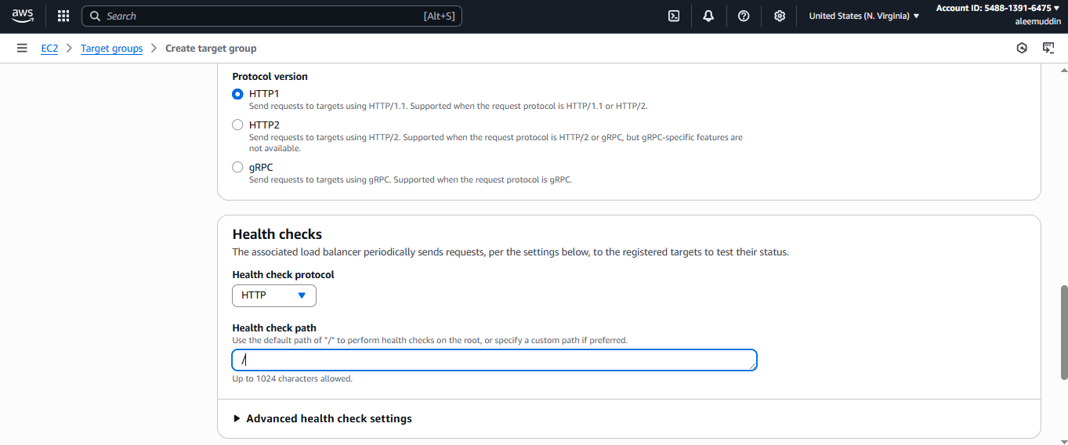

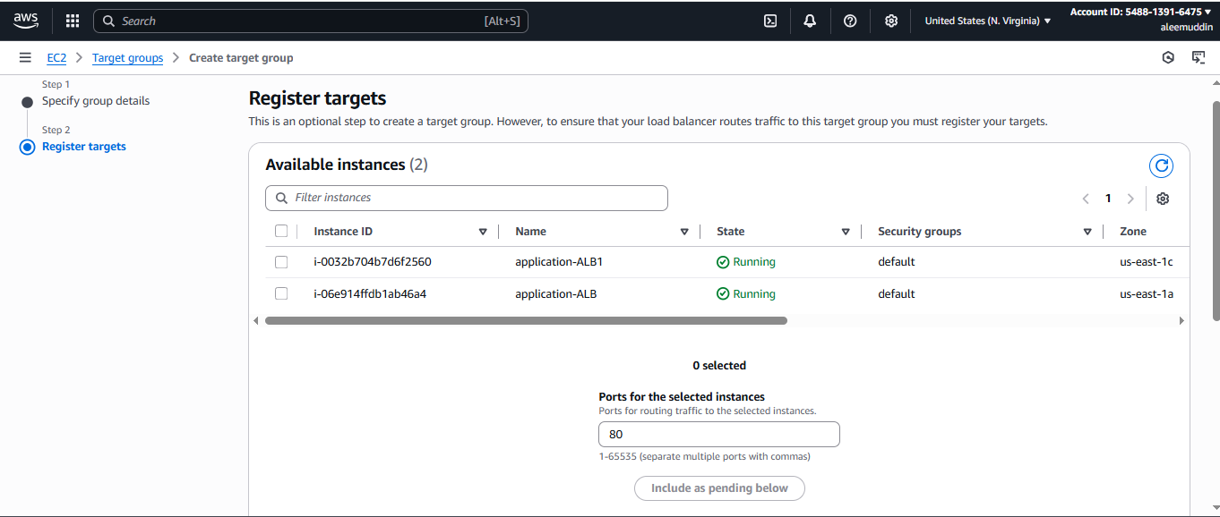

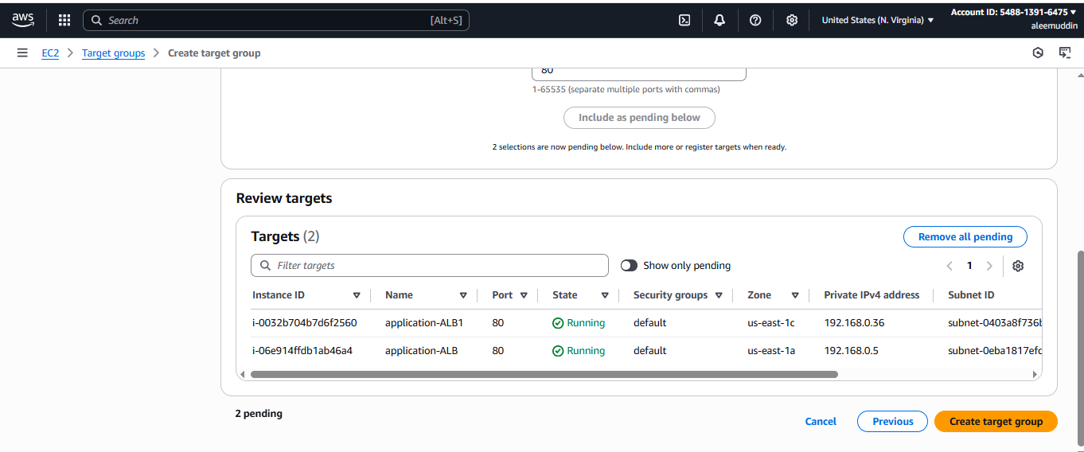

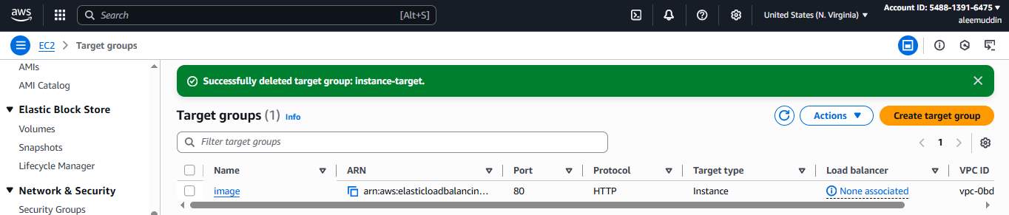

**Again back to load balancer and adding target group**

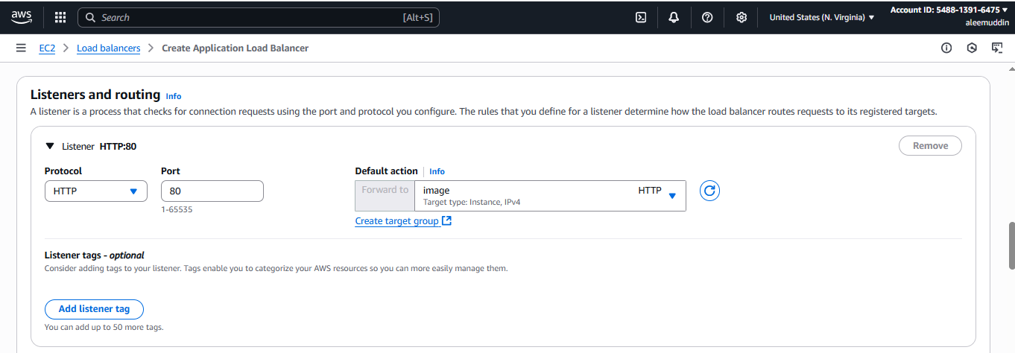

**Create load balancer then check status active or not**

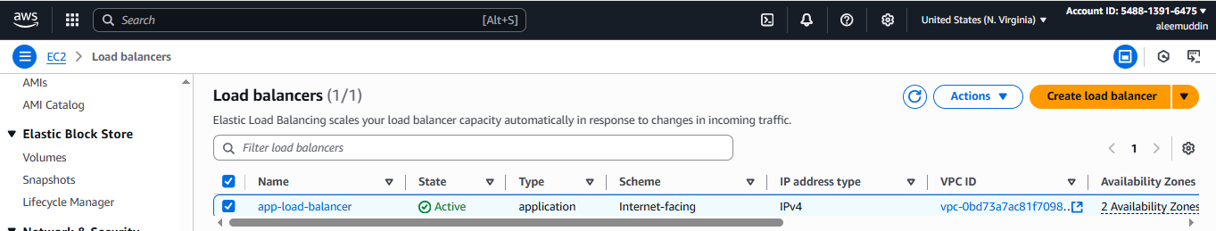

**If the load balancer status is active then go to target group and check the instance health.**

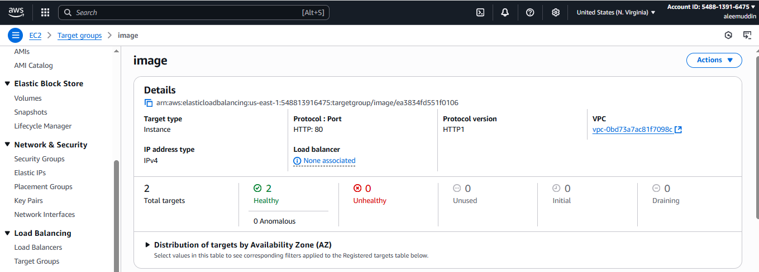

**Check on browser by pasting the domain name apache server is working or not.**

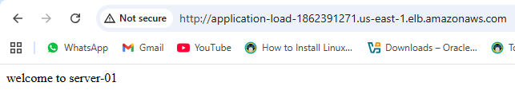

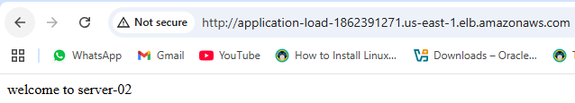

1. **Store Application load balancer logs to s3.**

**Step 1: Create an S3 Bucket for Logs**

1. Go to **S3 → Buckets → Create bucket**
2. **Name**: e.g., alb-logs-bucket-yourname
3. Choose Region (same as ALB)
4. Keep other settings default (or configure as needed)
5. Click **Create bucket**

**Step 2: Enable Access Logging on the ALB**

1. Go to **EC2 → Load Balancers**
2. Select your **Application Load Balancer**
3. Click on the **“Description”** tab
4. Click **“Edit attributes”**

**Step 3: Configure Logging**

1. Check ✅ **Enable access logs**
2. **S3 bucket**: Enter the bucket name (alb-logs-bucket-yourname)
3. (Optional) Set a prefix (e.g., logs/)
4. Click **Save changes**

**Step 4: Set Bucket Permissions (if needed)**

1. Go to the **S3 bucket**
2. Click **Permissions → Bucket policy**
3. Add policy to allow ALB to write logs:

json

CopyEdit

{

"Version": "2012-10-17",

"Statement": [

{

"Sid": "AWSALBLoggingPolicy",

"Effect": "Allow",

"Principal": {

"Service": "elasticloadbalancing.amazonaws.com"

},

"Action": "s3:PutObject",

"Resource": "arn:aws:s3:::alb-logs-bucket-yourname/*"

}

]

}

Done!  
Your **ALB access logs** will now be delivered to the specified **S3 bucket**.

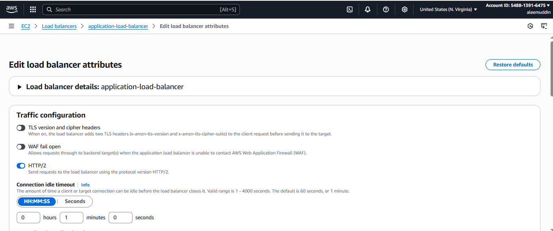

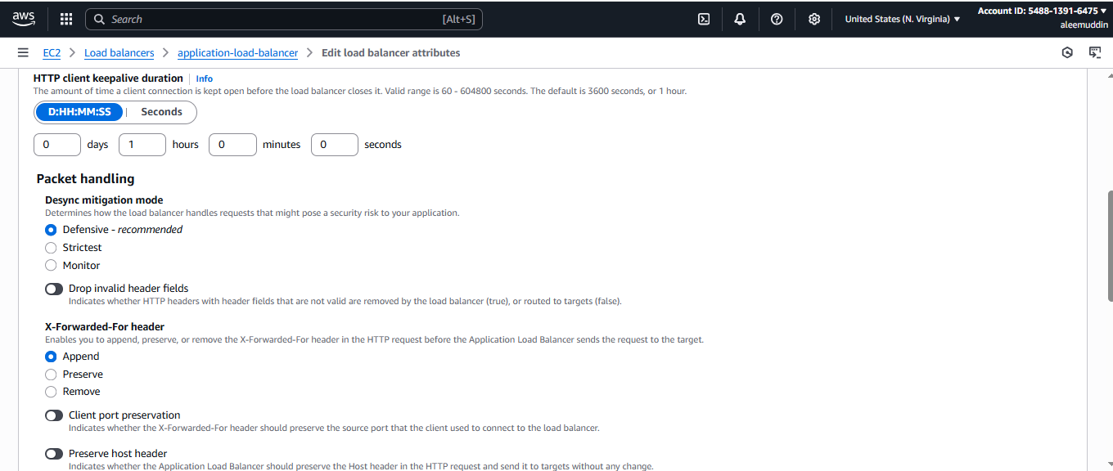

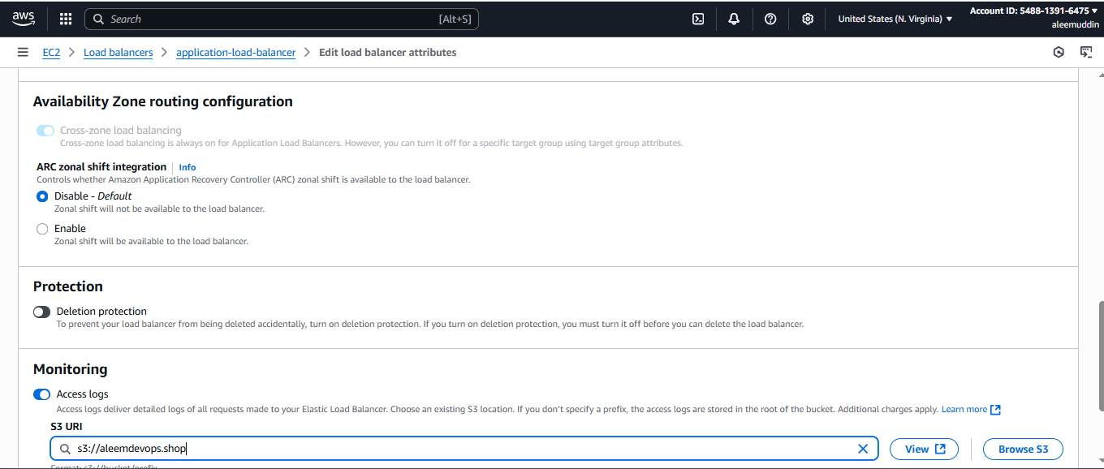

**Here we are login to s3 bucket to check the logs in bucket**

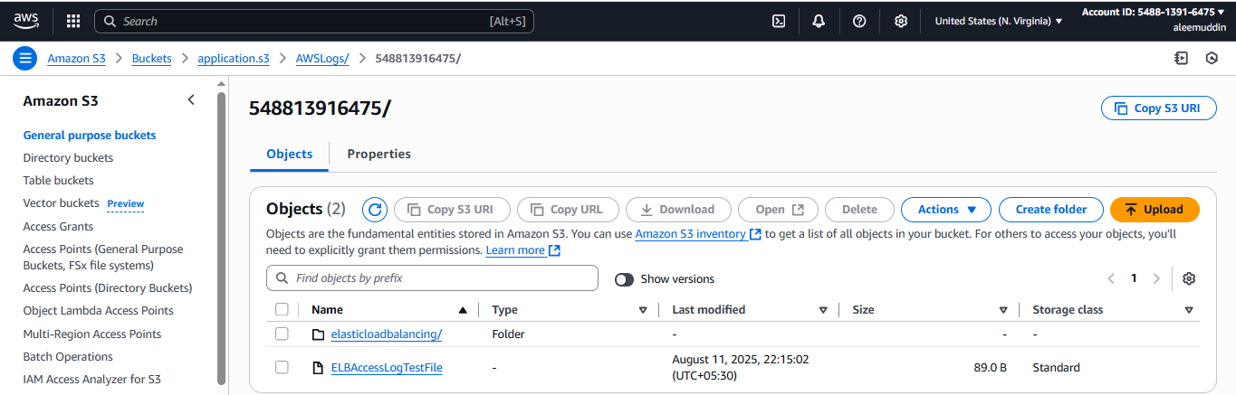

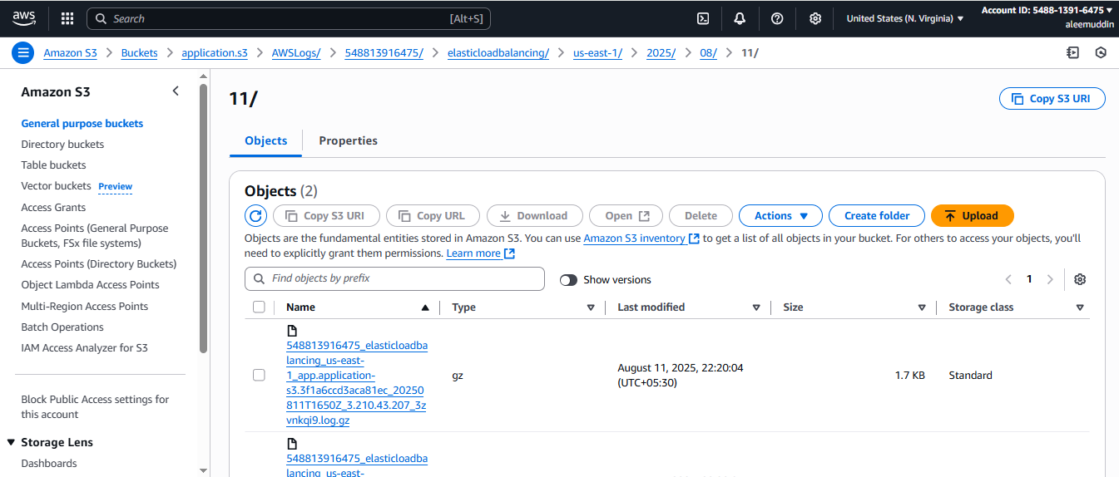

1. **Store the VPC flow logs to CloudWatch group.**

**Step 1: Go to VPC Dashboard**

1. **Open AWS Console**
2. **Navigate to VPC → Your VPCs**
3. **Select your VPC**

**Step 2: Create Flow Log**

1. **Click on “Actions → Create flow log”**
2. **Filter: Select All, Accept, or Reject (e.g., All)**
3. **Destination: Select Send to CloudWatch Logs**

**Step 3: Set Log Group and IAM Role**

1. **Log group:**
   * **Select existing or create new (e.g., /vpc/flowlogs)**
2. **IAM Role:**
   * **Choose existing role or click Set up permissions**
   * **AWS will auto-generate a role like FlowLogsRole**

**Step 4: Finalize and Create**

1. **Click Create flow log**
2. **It starts logging VPC traffic to the selected CloudWatch log group**

**Done!  
Your VPC Flow Logs are now stored in CloudWatch Logs, where you can monitor and analyze them.**

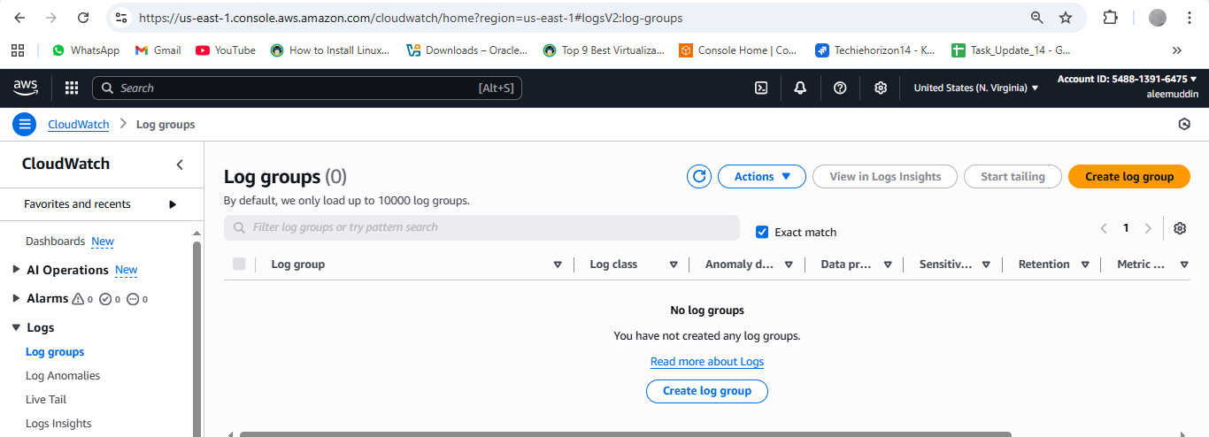

**Check cloudwatch having any Log group then go to IAM & create a role**

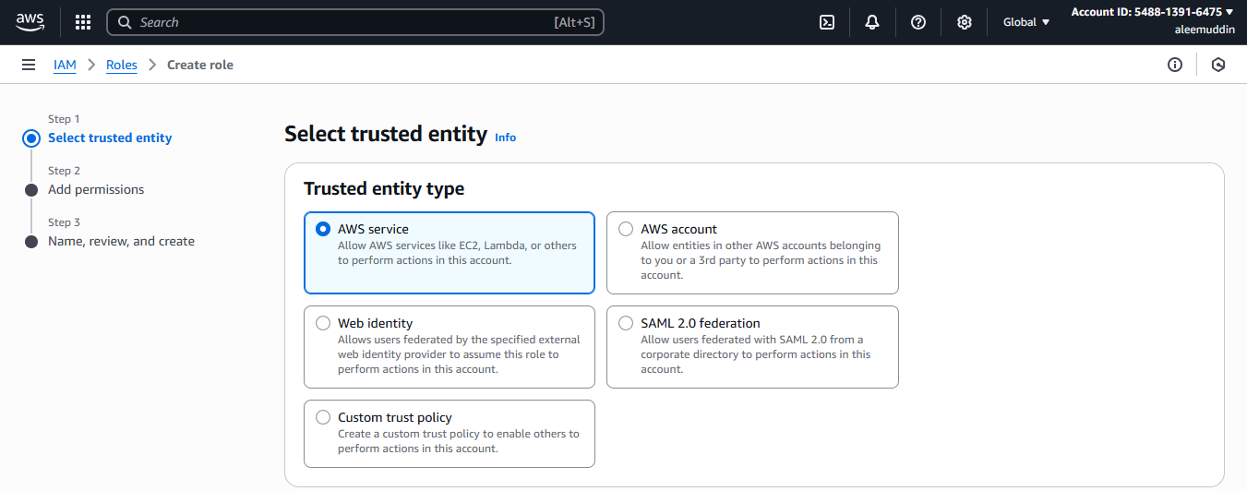

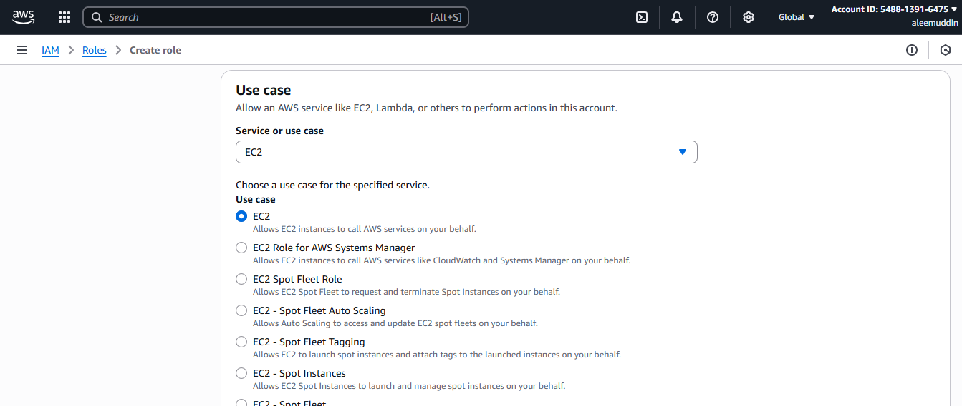

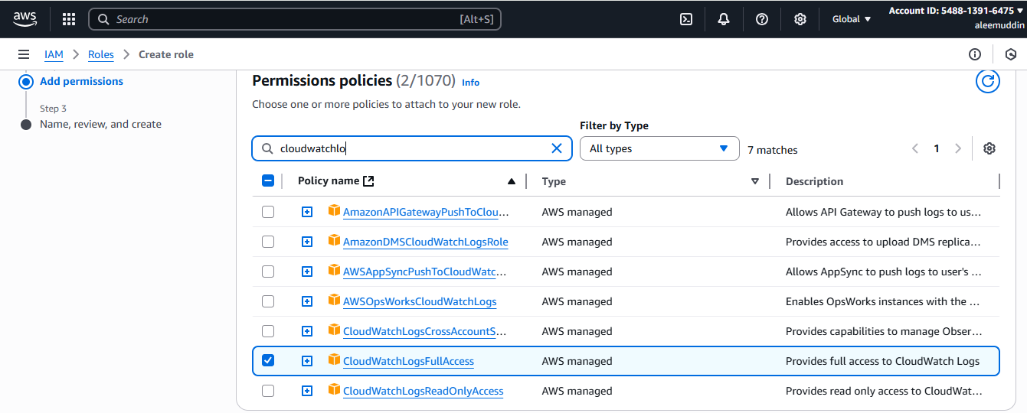

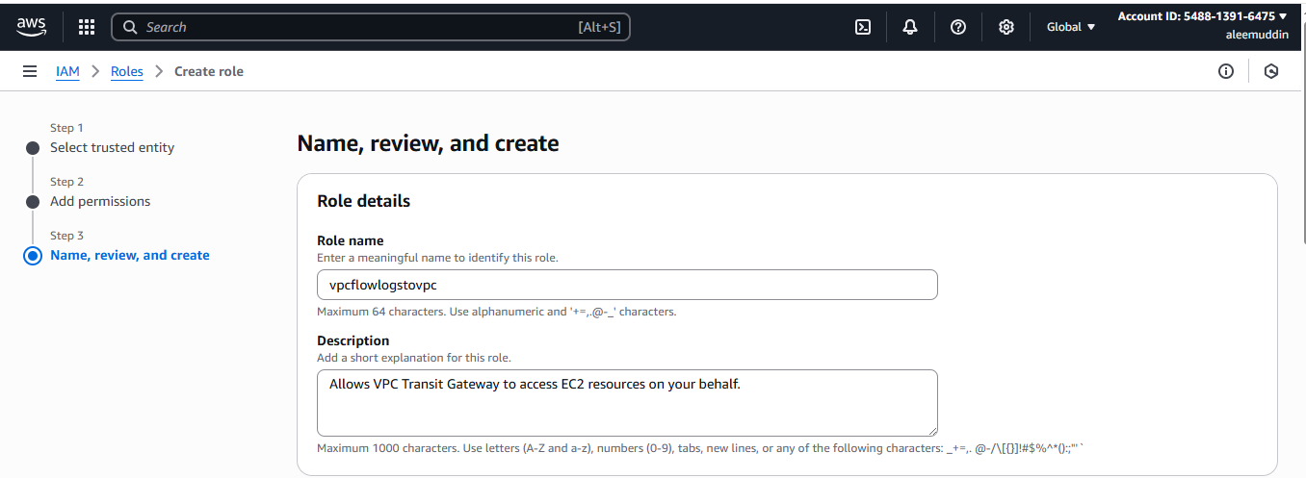

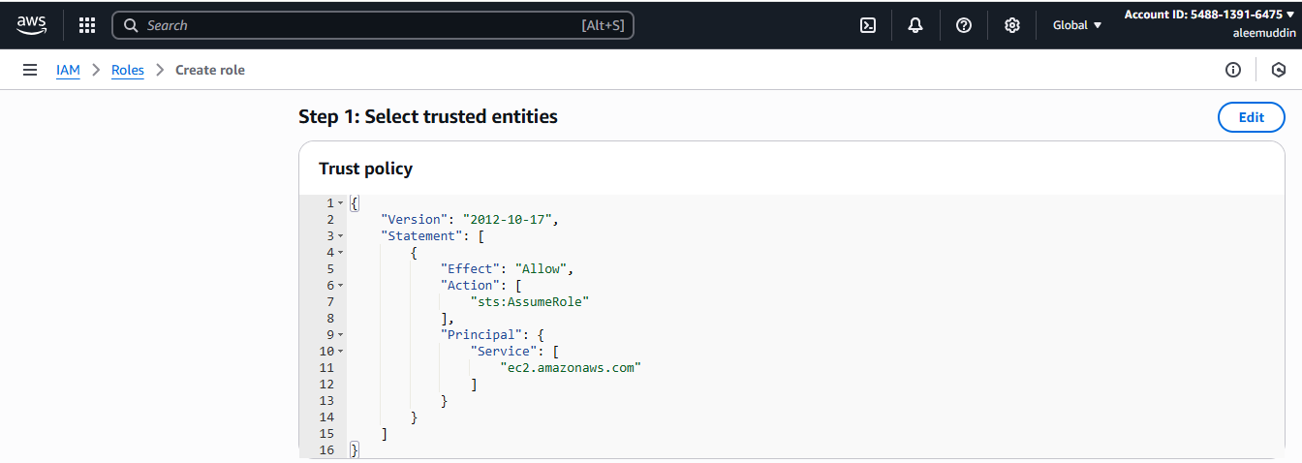

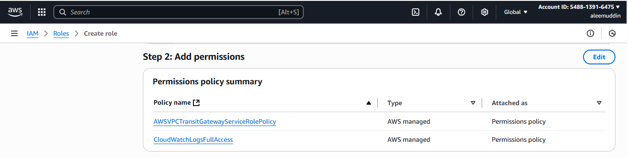

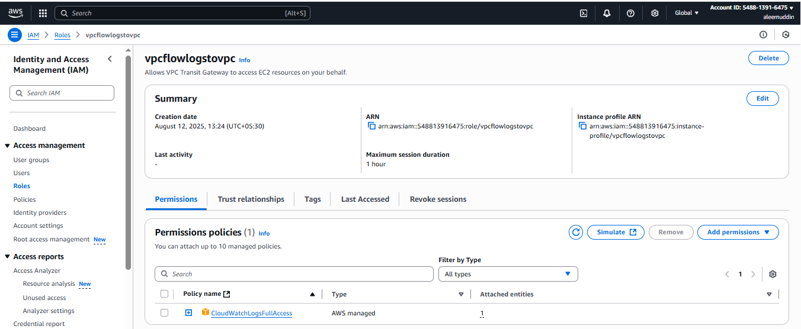

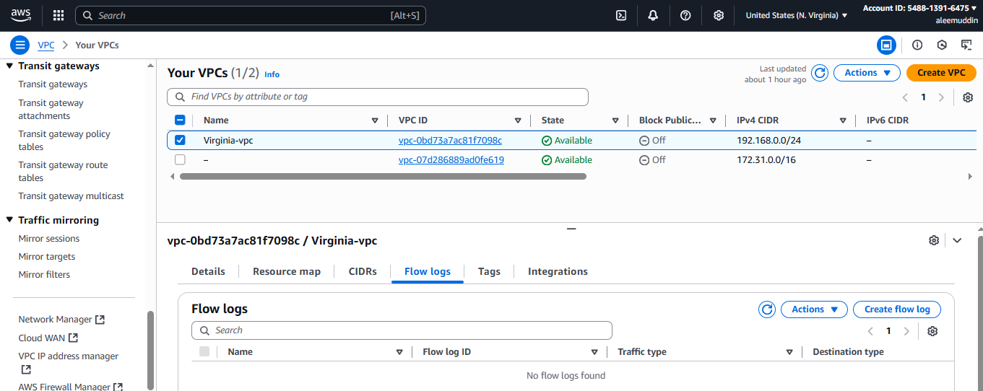

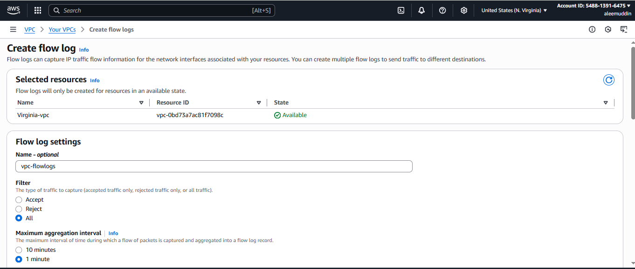

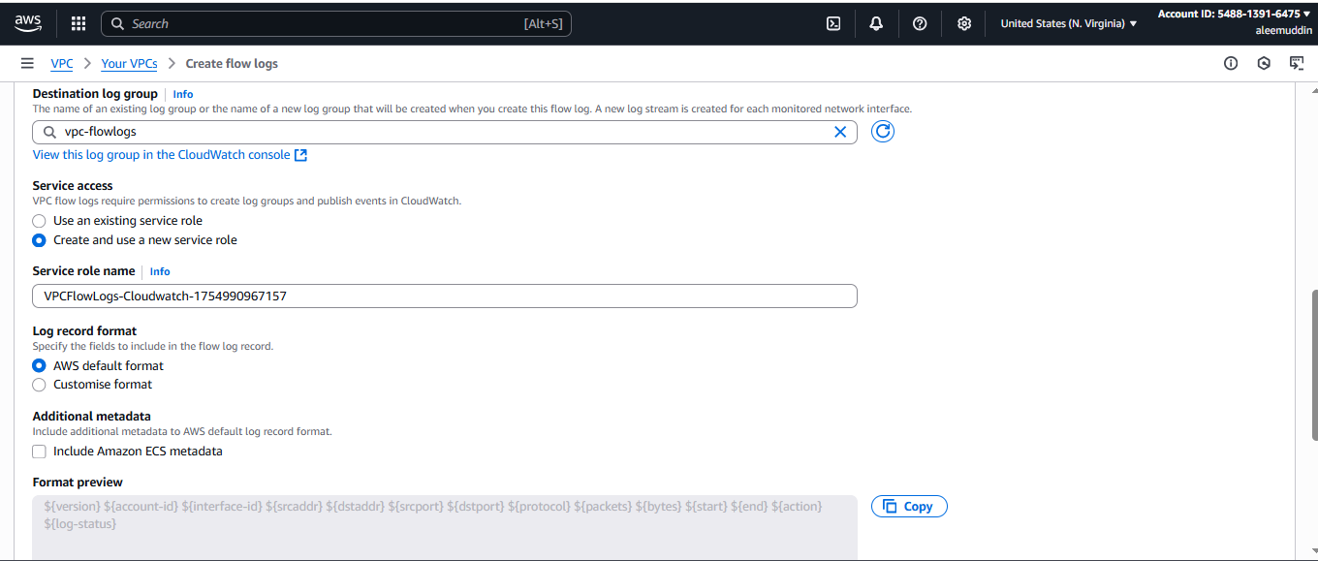

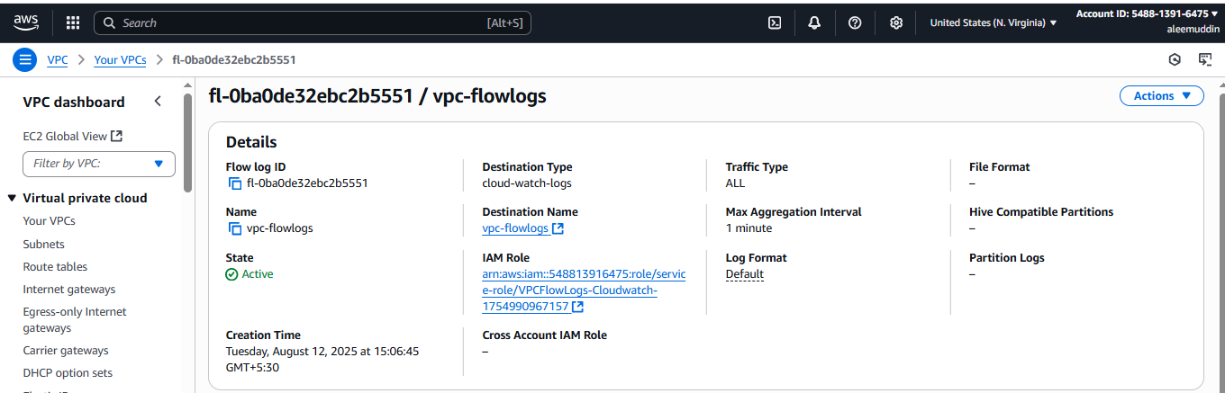

**Create vpc flow logs then go to cloud watch and check vpc flow logs it will reflect in log group>log stream**

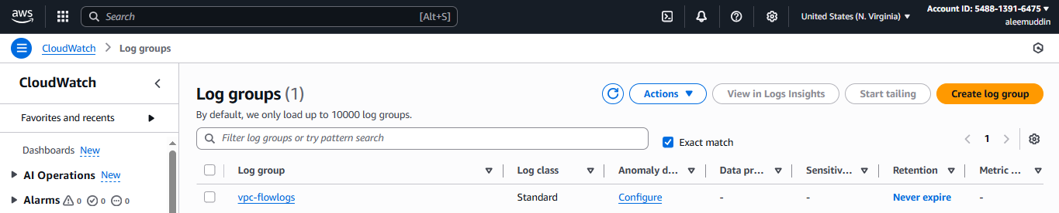

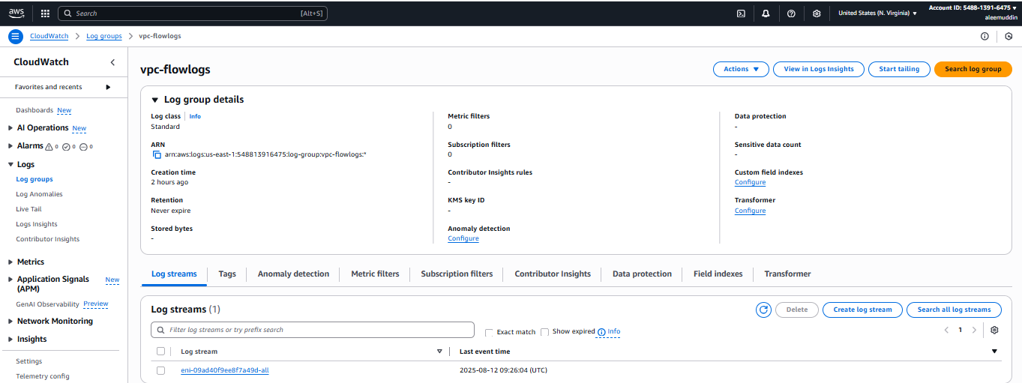

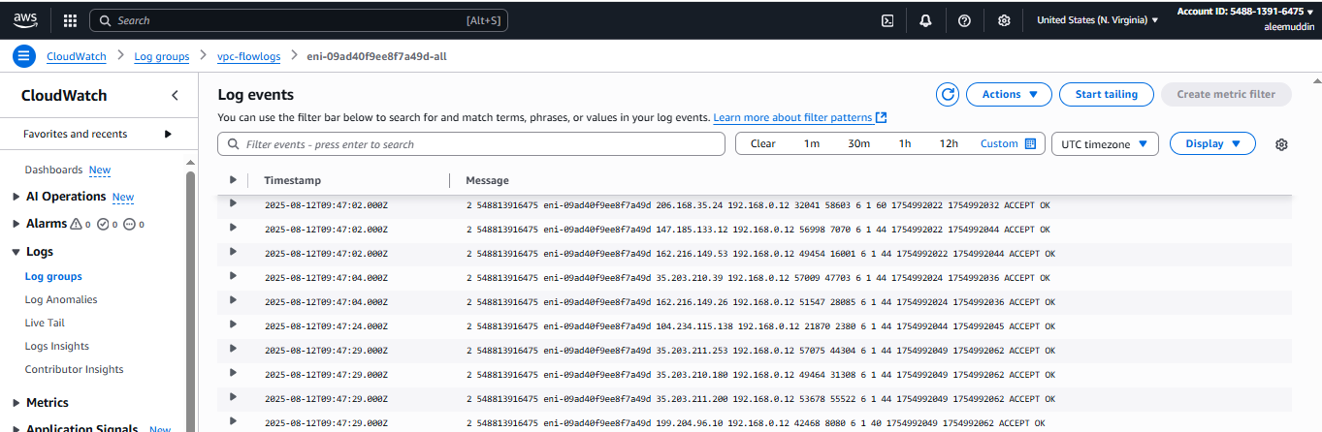

1. **Create Monitoring Dashboards to monitor CPU utilization and to monitor Apache service.**

**Step 1: Open CloudWatch Console**

1. **Open AWS Console**
2. **Navigate to CloudWatch → Dashboards**
3. **Click Create dashboard**
4. **Enter a Dashboard name (e.g., MyMonitoringDashboard)**
5. **Click Create dashboard**

**Step 2: Add CPU Utilization Widget**

1. **Choose “Line” widget**
2. **Click Configure**
3. **Under Metrics, select:**
   * **EC2 → Per-Instance Metrics → CPUUtilization**
   * **Select your EC2 instance(s)**
4. **Click Create widget**

**Step 3: Create Apache Service Monitoring Metric (Custom Metric)**

1. **On each EC2 instance, run a script or CloudWatch Agent to push Apache status (e.g., up/down) as a custom metric to CloudWatch (see note below).**
2. **Alternatively, create a CloudWatch Logs Metric Filter if Apache logs are pushed to CloudWatch Logs.**

**Step 4: Add Apache Service Widget**

1. **Back on the dashboard, click Add widget**
2. **Choose “Number” or “Line” widget**
3. **Select your custom Apache metric namespace**
4. **Select metric representing Apache service status**
5. **Click Create widget**

**Step 5: Save and Review Dashboard**

* **The dashboard now shows CPU usage and Apache service status.**

**Note: Apache monitoring script example**

* **Run on EC2 instance and publish custom metric to CloudWatch (e.g., status 1 if running, 0 if stopped).**

**Done!  
You now have a CloudWatch dashboard monitoring CPU utilization and Apache service health.**

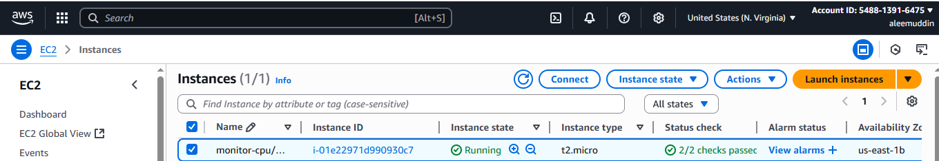

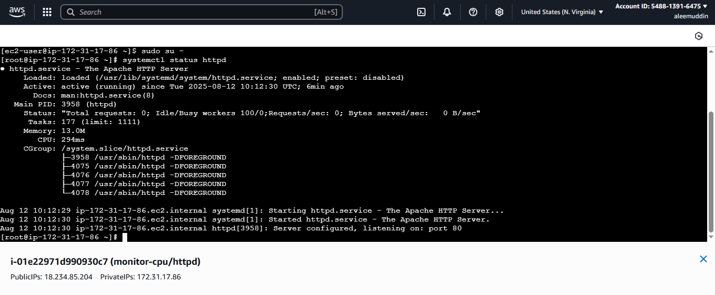



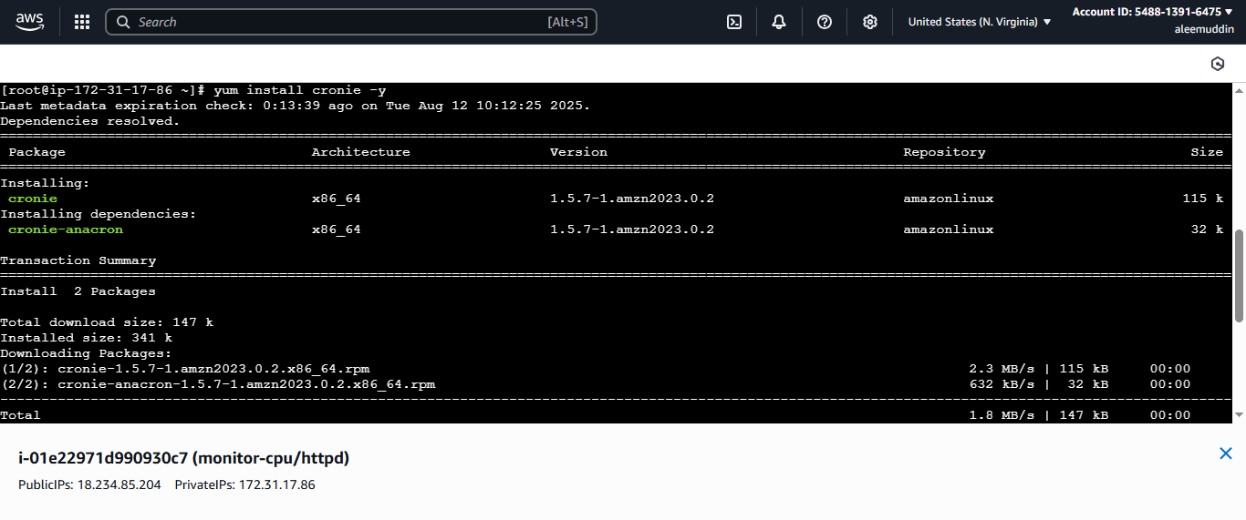

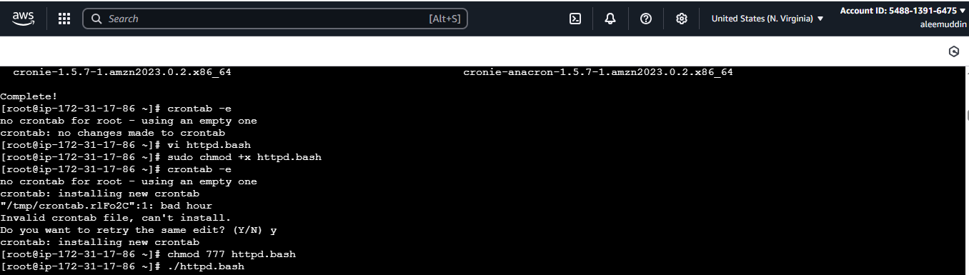

**Here we login to cloudwatch to create dash board and monitor cpu utilization & Apache service.**

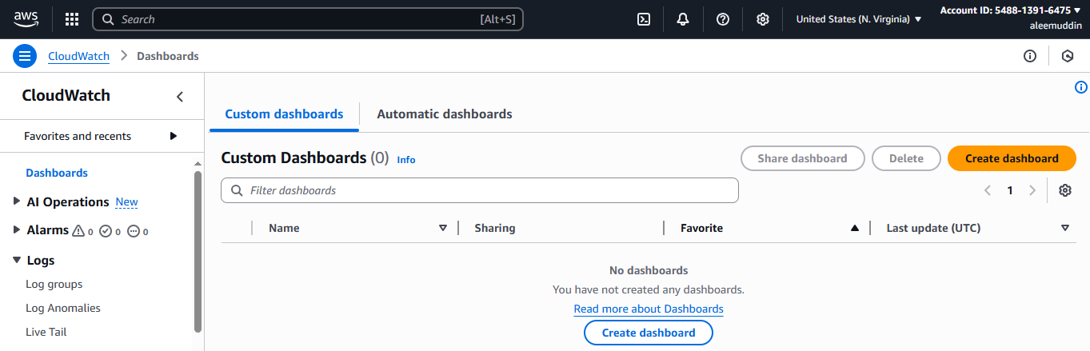

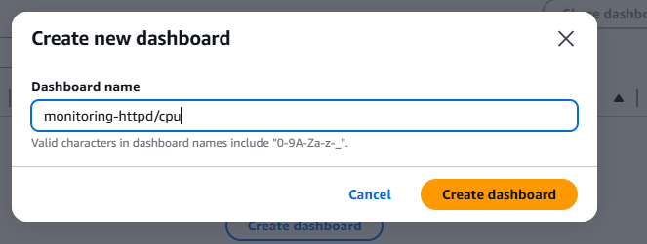

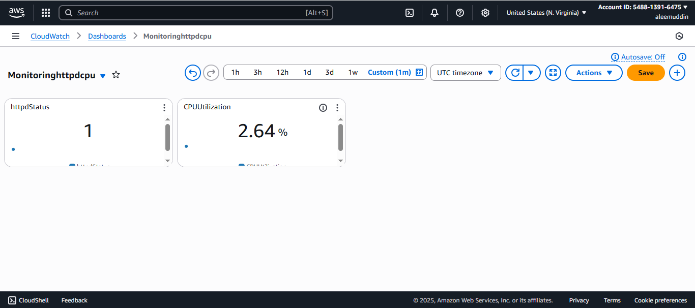

1. **CPU utilizations more than 70% then it should triggered Autoscaling and launch new instance.**

**Step-1: Create a Launch Template (or Launch Configuration)**

**This defines how new instances will be created.**

1. **Go to EC2 → Launch Templates → Create launch template.**
2. **Give it a Name (e.g., my-autoscaling-template).**
3. **Select AMI (Amazon Linux 2 or your custom image).**
4. **Choose Instance Type (e.g., t2.micro).**
5. **Set Key Pair (for SSH access).**
6. **Configure Security Group (allow required ports like 22, 80).**
7. **Click Create launch template.**

**Step-2: Create an Auto Scaling Group**

1. **Go to EC2 → Auto Scaling Groups → Create Auto Scaling group.**
2. **Select your Launch Template from step 1.**
3. **Name it (e.g., my-autoscaling-group).**
4. **Choose your VPC and Subnets.**
5. **Desired Capacity: 1  
   Minimum Size: 1  
   Maximum Size: (e.g., 5) — This is the max instances you allow.**
6. **Click Next until you reach “Configure metrics & scaling policies”.**

**Step-3: Attach a Scaling Policy for CPU > 70%**

1. **In the Scaling Policies step, choose Target tracking scaling policy.**
2. **Select Average CPU Utilization.**
3. **Set Target value to 70 (%).**
4. **Keep Instances warm-up time at 300 seconds (or adjust).**
5. **Click Create Auto Scaling group.**

**Step-4: Verify CloudWatch Alarm**

**When CPU > 70%, AWS automatically creates a CloudWatch Alarm linked to your Auto Scaling group.  
You can check it in CloudWatch → Alarms.**

**Step-5: Testing**

* **Manually put load on your instance (e.g., using stress command on Linux):**

**bash**

**CopyEdit**

**sudo amazon-linux-extras install epel -y**

**sudo yum install stress -y**

**stress --cpu 4 --timeout 300**

* **Once CPU > 70% for a few minutes, the scaling policy will trigger and launch a new instance.**

**Result:**

* **When CPU > 70% → Auto Scaling launches new instance.**
* **When CPU goes back to normal → You can configure a scale-in policy to terminate extra instances.**

